**Setup DB at your local:**

I extracted DUMP sample database file from my RavenDB (version: 2.5.2916). You can import it into your ravenDB (by go to Task menu, and Import Database file).

By default, I’m using connection string is :

<add name="Default" connectionString="Url = [http://localhost:8080;DefaultDatabase=Sample"/](http://localhost:8080;DefaultDatabase=Sample%22/)>

You can free to modify to match with your local environment by changing it in Web.config in ***SinglePageSample.WebAPI*** project.

If you cannot import, then:

* Firstly you should make sure you have ravendb at your local,
* and next create a database with name ‘**Sample’,**
* and after then run CompanyRepositoryTests test file under SinglePageSample.UnitTest project. this test will automatically create 200 companies.

For employee, you can create by manually, no need script or importing (of-course the sample web application also can run without initialed data, data is need for paging testing and remoting load data purpose)

In case you cannot compile source, please try to turn-on Enable Nuget download feature, some libraries I reference from Nuget)

**Some introduction:**

Index page: there are 2 links which navigate to Company List and Employee list page

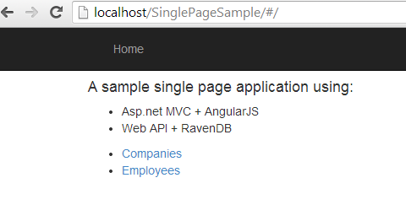

Company list page: there are has 2 links on the Employee column (one to view all employees on this company, and one to add employee into this company)

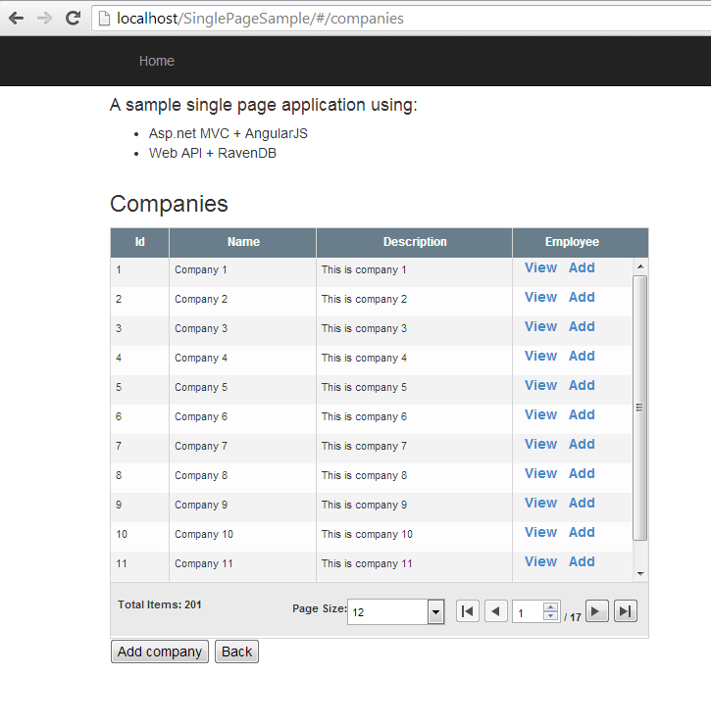

Below picture is showed when you click View link:

***All employees are working for Company 1, here we can search employee by name***

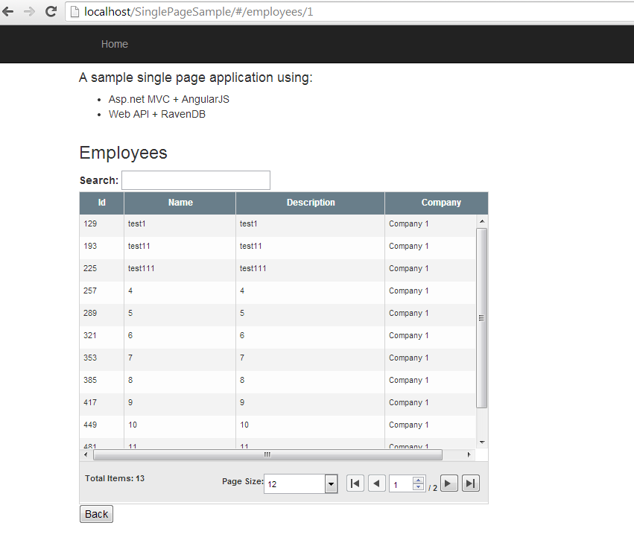

For example, we search employee with name ‘test’, the result as below picture (as the Total items found also be changed accordingly):

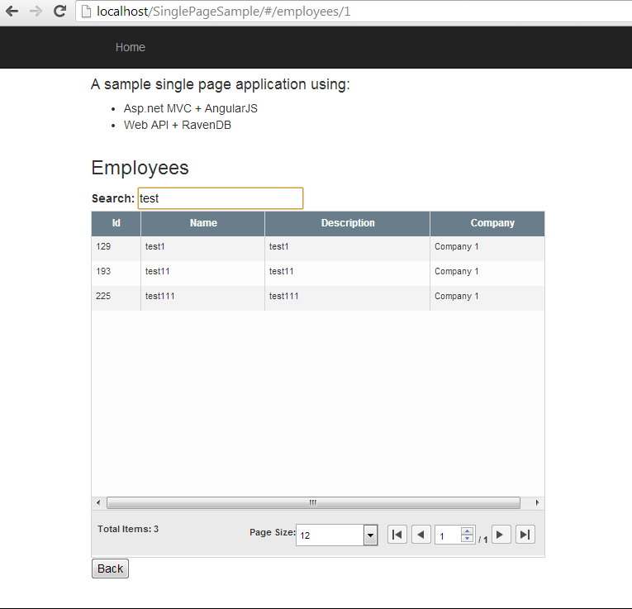

Employees list can be navigated from the link at the index page, show all employees of all companies

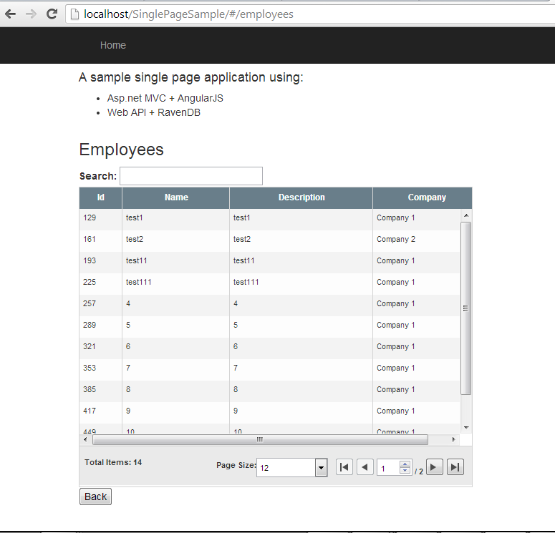

**Some code structures:**

**Front-end layer**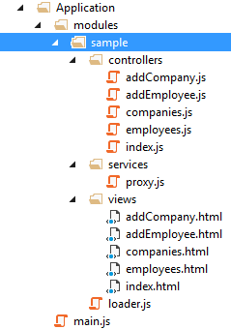

**Persistence layer**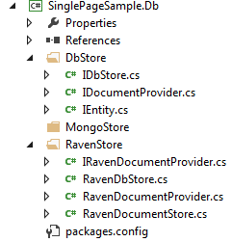

**Utility** 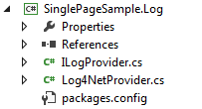

**Repository layer**